Lab - Using Cisco Webex Teams for Developers List Rooms API (Instructor Version)

In this lab, students will have their first experience using Cisco Webex Teams for Developers. Using only their access token, students will use the Listing Rooms service endpoint to make an API call that will list their Webex Teams rooms.

1. Objectives

* Send an API request using Cisco Webex Teams for Developers to list Webex Teams rooms

1. Background / Scenario

In this lab, you will use you Access Token and Cisco Webex Teams for Developers to make an API request to list your Webex Teams rooms. You will then use the id for one of your Webex Teams rooms to make another API request to list all the messages for that room.

1. Required Resources

* Cisco Webex Teams account
* Cisco Webex Teams desktop application
  + 1. Investigate the documentation for the Rooms API.

The **Rooms** API is used to manage the rooms themselves, including listing, creating, updating, and deleting rooms. Under **WEBEX TEAMS API**, click **Rooms**. Note the HTTP methods that are available here. We are going to use the GET API method to retrieve a list of rooms associated with an account:

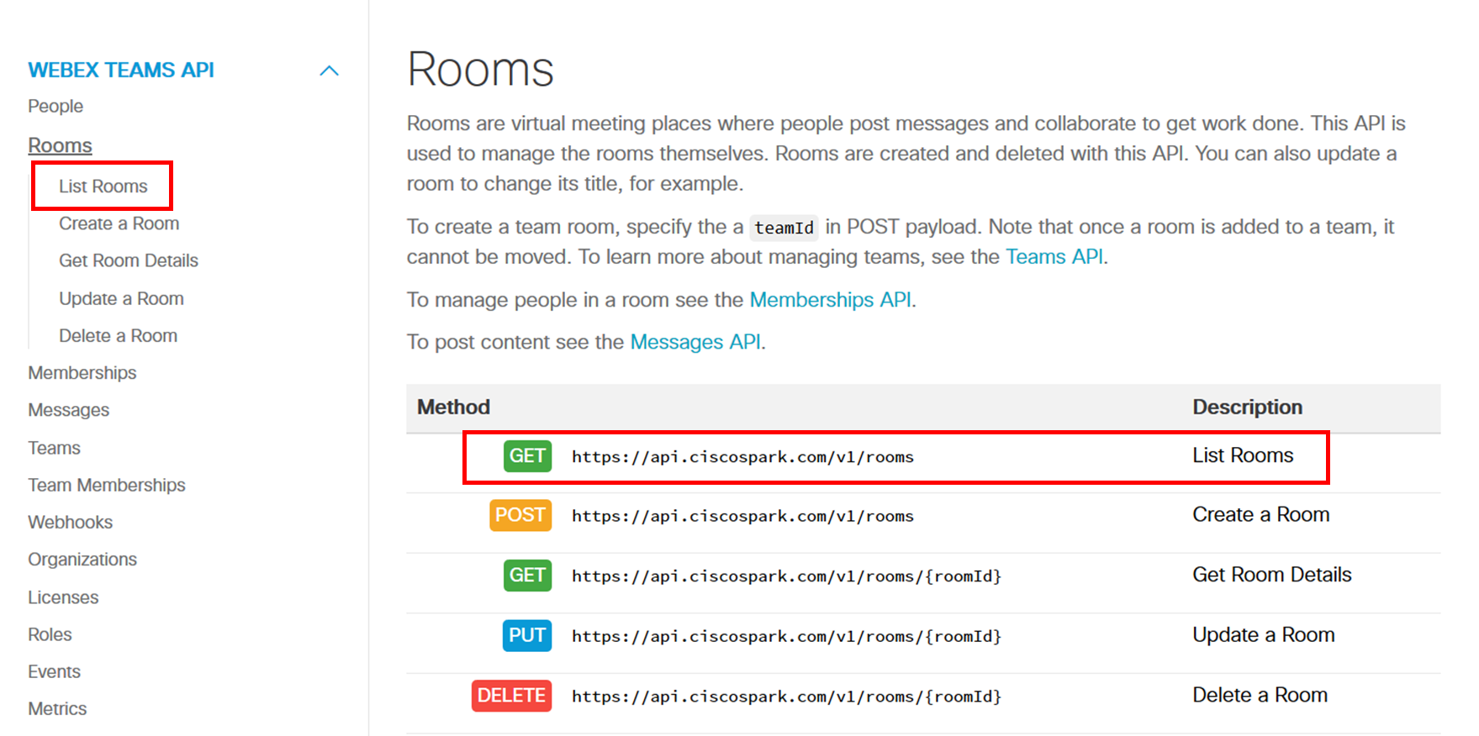

* + 1. Investigate the List Rooms method.
       1. Select **List Rooms** in the API Reference column.
       2. The Request Headers section of the page allows entry of information that will be passed to the API server in the headers section. As we can see, Content-type was set to **application/json; charset=utf-8** and **Authorization key** has the value **Bearer** followed by your access token, which was included automatically.

Your access token is prefaced by the word “Bearer” followed by a space because the value is known as a bearer token. The IETF defines the use of a bearer token as; “Any party in possession of a bearer token (a "bearer") can use it to get access to the associated resources (without demonstrating possession of a cryptographic key). To prevent misuse, bearer tokens need to be protected from disclosure in storage and in transport.”

**Query Parameters** are used when we want to query information regarding a particular value. If the query parameter is mandatory, then the **Required** column will have a check. In this case, there are no required query parameters. Clicking the **circled-i** at the end of each parameter, (  ) gives you an explanation of the parameter. A listing of the **Response Codes** are displayed below the parameters.

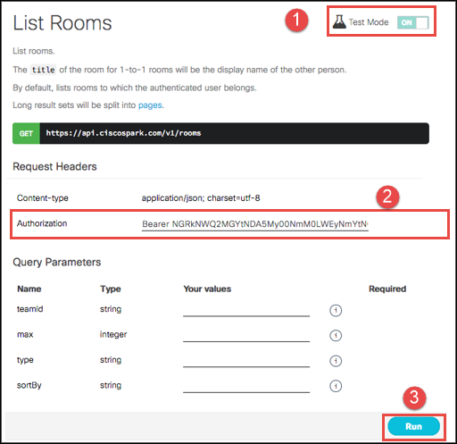

* + 1. Send a request for the List Rooms API and investigate the JSON response.
       1. Be sure that **Test Mode** is set to **ON**. (You may need to refresh the page to see Test Mode.)
       2. Click **Run** to send the API call and retrieve a list of your rooms.
       3. The response code should be **200 / success**. If it is something other than this, check to make sure your access token is correct and preceded by the word **Bearer** and a space.

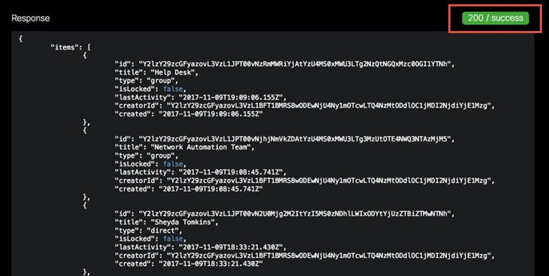

* + - 1. Notice that the list of rooms is displayed in the JSON format. The **id** value is used as a key to uniquely identify each room. Other information in the JSON output includes the name of the room (**title**) and the ID of the person who created the room (**creatorId**).
      2. Choose a room that you know has messages and copy the **id** information (the long alphanumeric string of text) following the **id** key. Do not include the quotes in your selection. (Be sure this is a room that you or others have posted messages to.) The ID information uniquely identifies this room and will be used in the next step to obtain list all the messages for that room.
    1. List messages for a specific room using the roomID query parameter.
       1. Select **Messages** in the API Reference column. Select **List Messages** in the WEBEX TEAMS API column or as listed under **Method**.

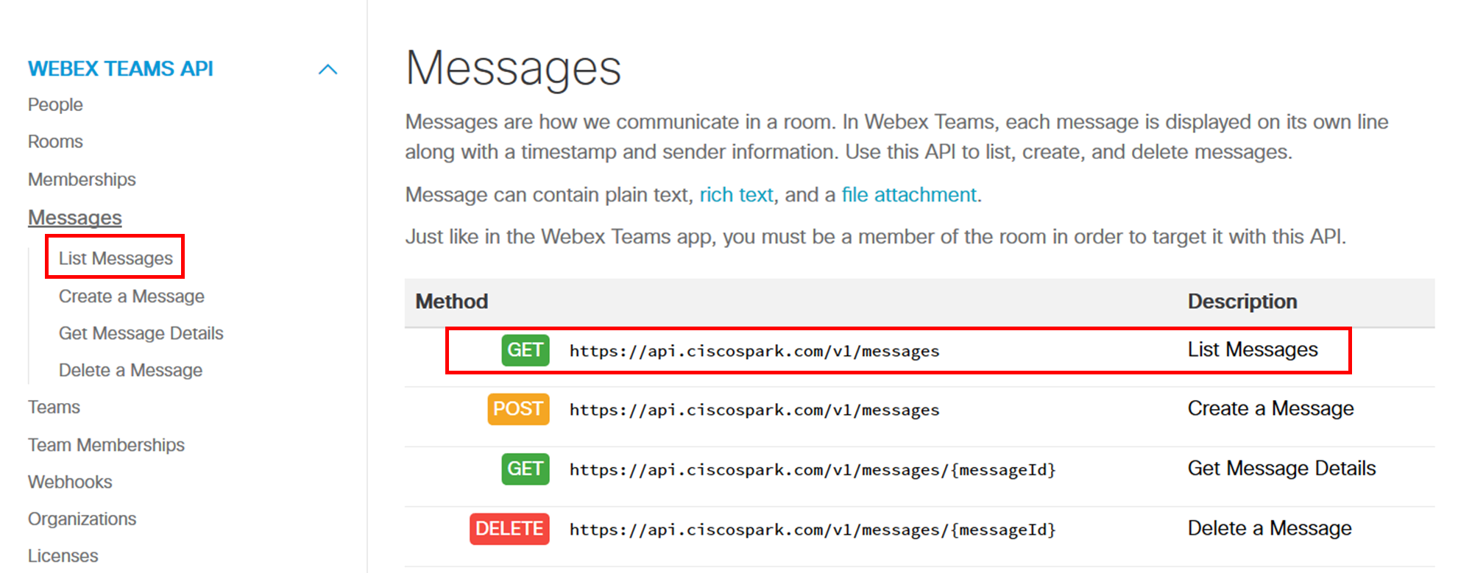

* + - 1. For the **roomid** Query parameter, paste the ID information you copied in the previous step. Notice that this is a required field.

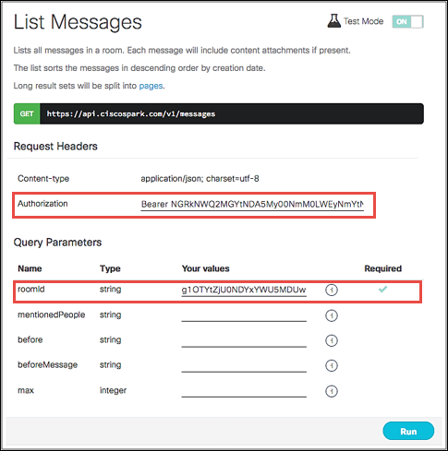

* + - 1. Click **Run.** Select a message and examine the **text** key of the JSON output. Compare the response JSON to the messages for the room that are displayed in the Webex Teams application.

